

Lab 5. Create an Enterprise Data Layer
The next layer to build are the models in the EnterpriseDataLayer folder. What these models do is resolve the slight semantic differences between the EU_Customer and US_Customer database tables – for example, the US version includes a field for middle initial only in the customer table where the EU version of the customer table has a corresponding field for middle name. Now, one technique we use here to make resolving the semantic differences a little bit easier here is to convert all of the data types for these tables from the standard SQL datatypes to one of a set of custom datatypes we've defined using JBoss Data Virtualization's data dictionary capabilities. This way we can ensure that we get all data for a particular field into the same datatype. It also gives us a guide to resolving any differences in field names between the two. Note that using a domain-specific (or enterprise-wide standard) data dictionary is only a recommendation. There is no hard requirement to define or use a data dictionary but instead do this semantic mediation without one (by manually comparing datatypes and field lengths between the two data sources). Our goal with JBoss Data Virtualization is to not impose any roadblocks for those users that want to get their use cases addressed as rapidly as possible – so we don't force any requirement on users to define a data dictionary or a taxonomy or anything like that.
5.1 Import the Data Dictionary Schema
An XML schema containing the definitions of a number of datatypes applicable to the FInancial domain used by this lab is located in /home/lab9/Desktop/eds. The name of the file is DataDictionary.xsd. We want to import the schema into the Schemas folder that was created in an earlier lab. Perform the following steps.
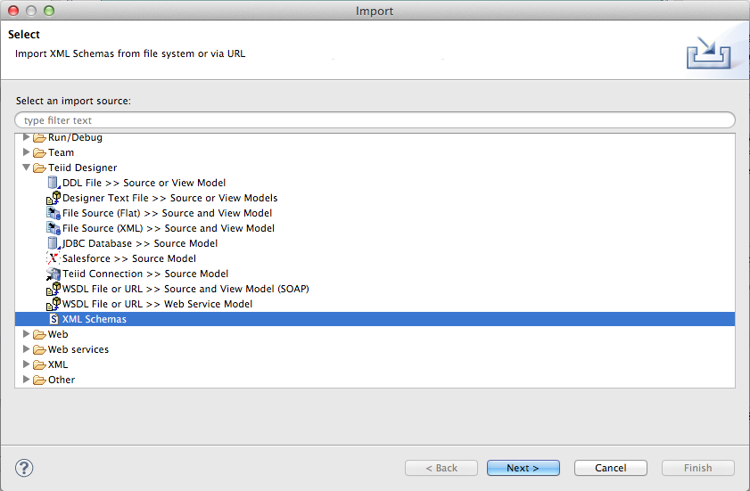
Right-click on the Schema folder in the Model Explorer and choose Import → Teiid Designer → XML Schemas. Then click the “Next >” button.

Choose to import the schema from the file system and click “Next >”.
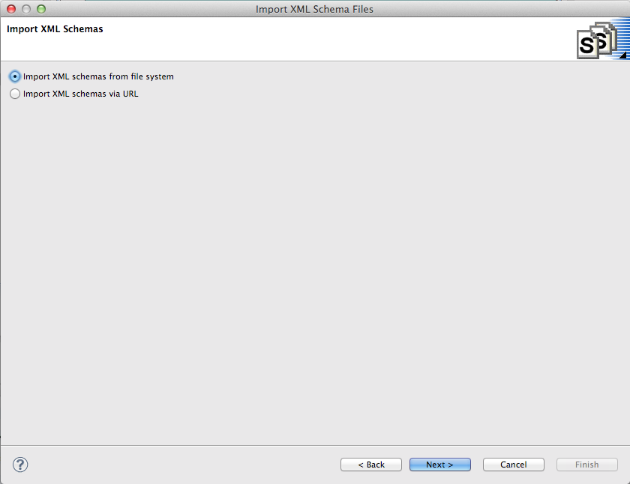

Browse to the {install directory}/dv6_lab directory. Once the directory is opened in the “From Directory” field, you will be able to select (checkbox) the DataDictionary.xsd file. Then click “Finish”.
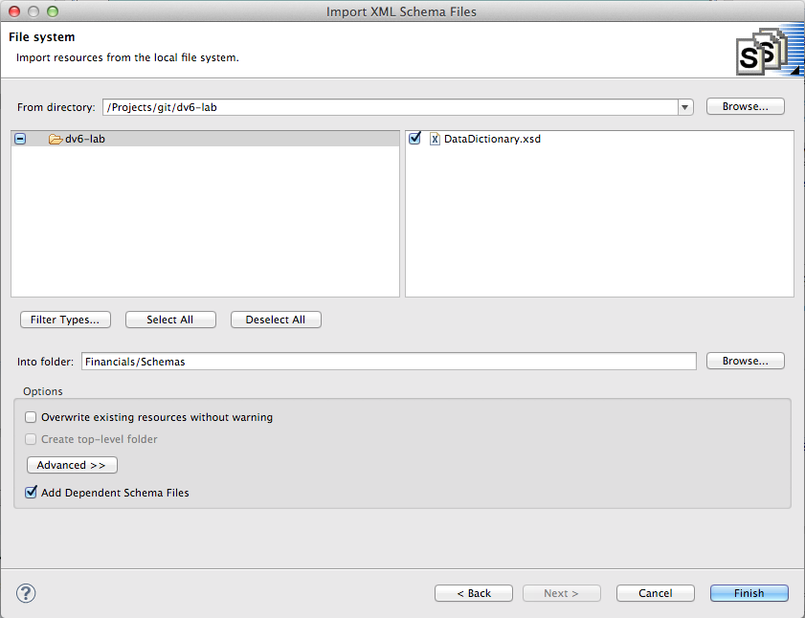
You may get a warning that the Financials/Schemas already exists. Choose yes to overwrite.

5.2 Examine the Data Dictionary
Double-click on the DataDictionary.xsd file you just imported to open the XML Schema viewer. This is a very basic viewer that allows you to see the design model, the source (note the tabs at the bottom), and choose any of the data types to view it's properties (in the Properties tab to the left). The schema can be edited/created here, but most customers use XML-specific tooling to create these files.
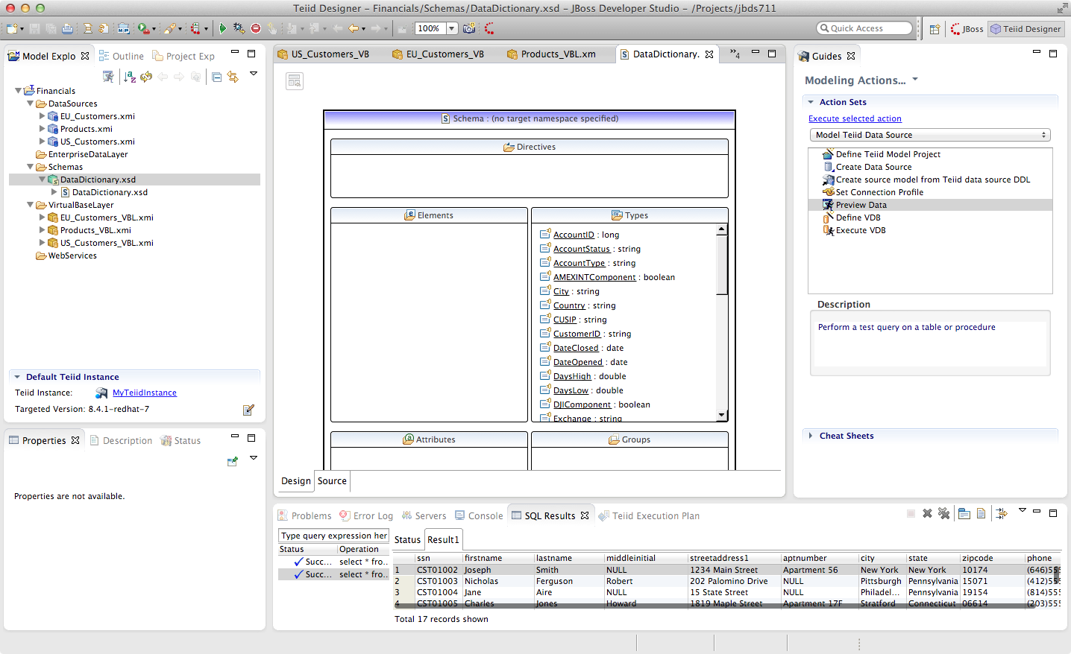

5.3 Create the EU_Customers_DDC Enterprise Data Layer
Create a new virtual metadata model called EU_Customers_DDC (for Domain Data Dictionary) under the EnterpriseDataLayer folder. Right-click on the folder EnterpriseDataLayer and select New → Teiid Metadata Model to bring up the New Model Wizard and make the following selections as indicated in the illustration below.
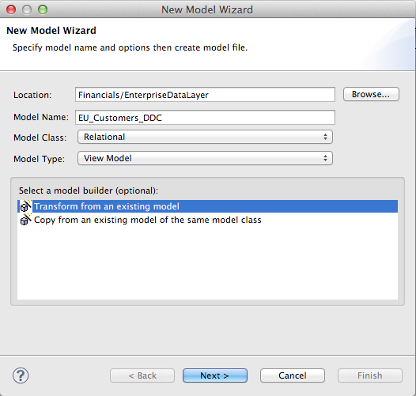

Click “Next >” to go the next step of the New Model Wizard.

This time, use the EU_Customers_VBL as the model as the basis for the DDC model and click “OK” and “Finish”.
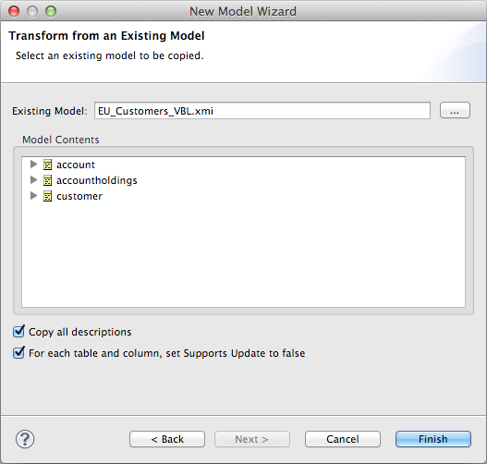

We are going to use the database schema of the EU_Customers database as the standard upon which to base our enterprise model. Therefore we won't be changing any of the table names or column names, but we will be modifying the transformation to incorporate our Data Dictionary. When we get to the transformations for the US_Customers and EU_Customers DDC models we will see that more changes will be necessary to make them semantically align with our enterprise model.
Open the transformation Editor for the Customer table of EU_Customers by double-clicking on it. Select CustomerID and note that there is a Datatype field in the Properties Panel on the lower left.

Click on the value field to the right of datatype in the Properties Panel in the lower left-hand side of JBDS.
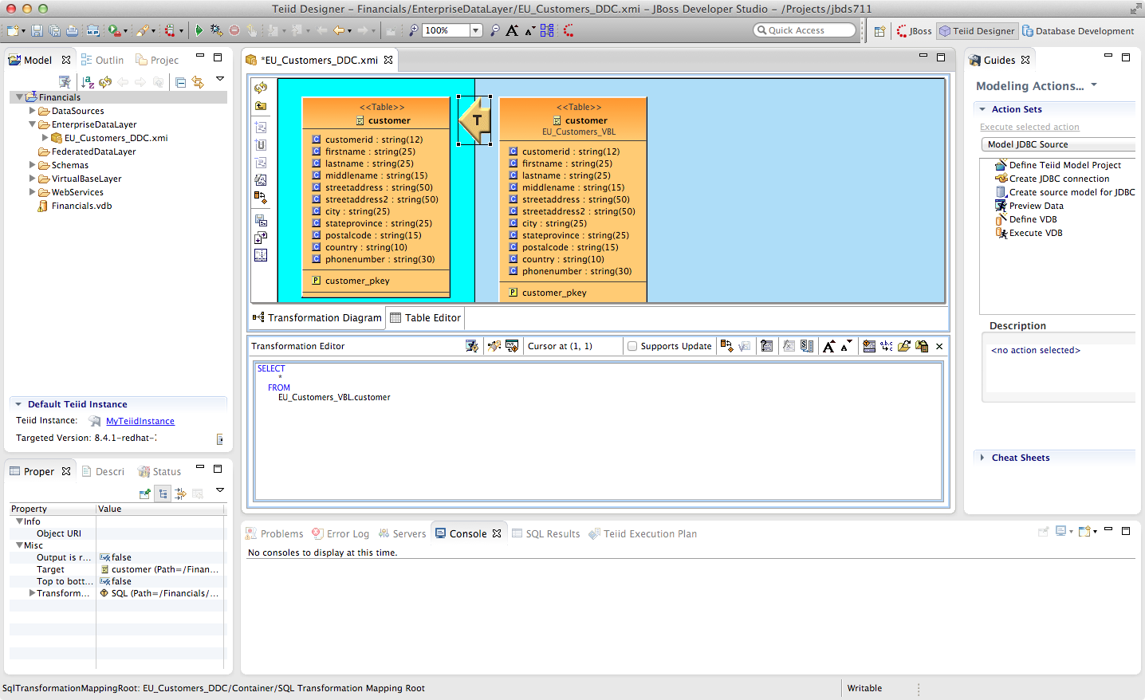
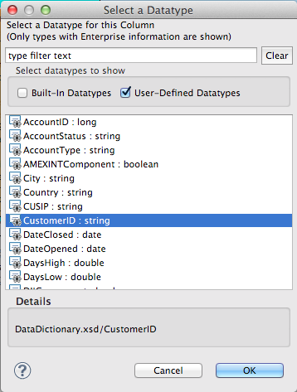
When clicking in this field in the Properties Panel, the Select a Datatype Wizard is presented. The User-Defined Types were populated when we imported the DataDictionary.xsd schema. Browse through the datatypes, check and un-check the boxes to see which types are built-in and which are user-defined.
In the “Select a Datatype” window choose CustomerID user-defined type for the CustomerID column and click “OK”. You can begin typing the name of the datatype in the top window to filter the selection types displayed.
Go through this exercise with every column in the Customer table choosing the appropriate datatype for each. Be sure to save your work. At the completion of the exercise, your Customer table should look like the one below.
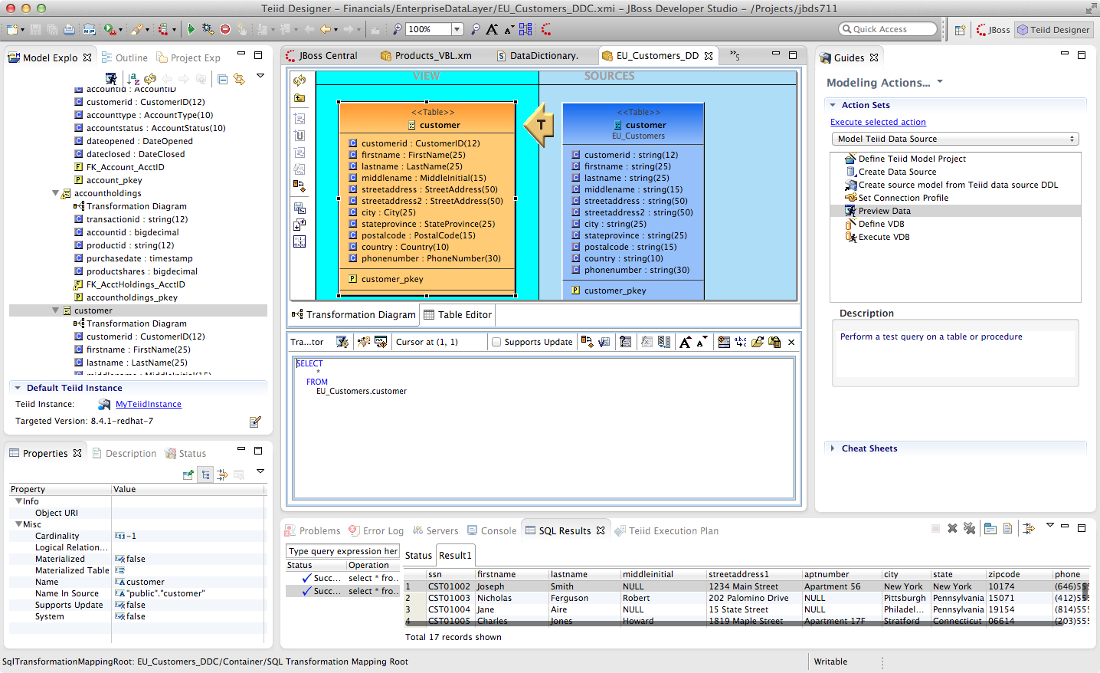
Perform the same process for the other tables (Account, AccountHoldings) in the EU_Customer_DDC model. A way to "go back" to the parent model is to right-click on the teal background surrounding the View model and select "Show Parent Diagram". Alternatively, you can select the table you want to work with by double-clicking on it in the Model Explorer tree-view.
Note: however when you save your changes the following warnings appear in the Transformation Editor:
The SELECT transformation is valid, but NOT fully reconciled:
The transformation output types do not match the target attribute types.
This is because some of the enterprise datatypes we have chosen do not match the underlying format of the source data (AccountID, for example we are defining as a long, but it is a bigdecimal in the source).
To address these type mismatches we will open the Reconciler. This is done by clicking on the small icon just to the right of "Supports Update" in the Transformation Editor.

Clicking on the Reconciler for AccountHolding brings up the following view.
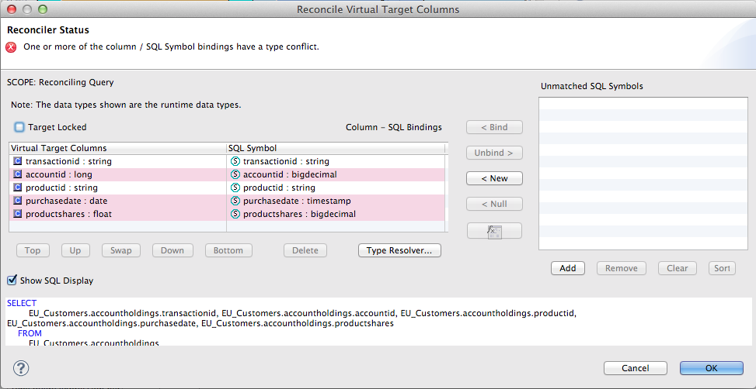
Note the highlighted fields that indicate problems. We can address all of these in one go by clicking on the Type Resolver... button. That will bring up the following wizard.
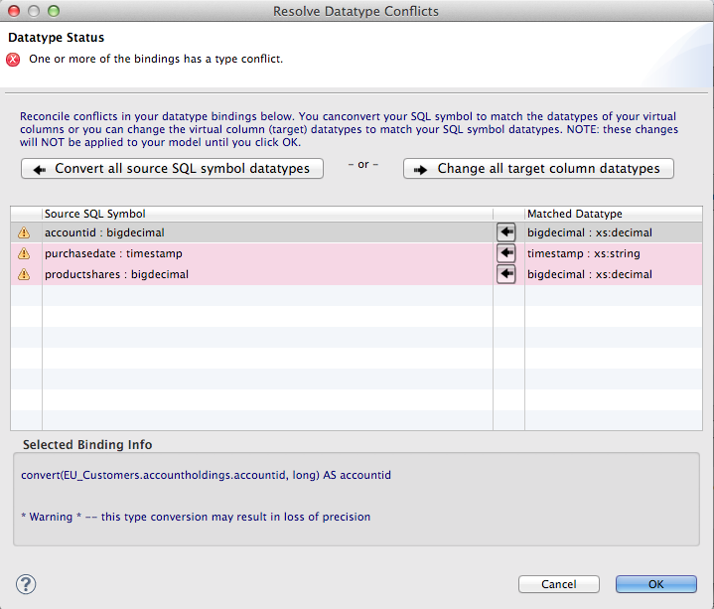
Select each mapping at the top and see that the proposed transformation at the bottom changes. This is under the SQL Symbol panel; we want to convert to the datatype that is assigned to the enterprise datatype. (The Virtual Target Attribute section of the wizard above lets you modify that datatype; we don't want to do that here.)
Note that there are three different type mappings being handled here: bigdecimal to long, timestamp to date, and bigdecimal to float. We are not worried about precision in this case, so we can simply press the “Convert all button (the second one, in the SQL Symbol section), followed by clicking “OK”. This will return you to the Reconciler. Note that the SQL has been re-written in the transformation to handle all the type conversions. Click “OK” on the Reconciler to finish the process.
Now go back and perform the same steps with the account table.
If we were worried about precision, we could take any number of steps to refine/modify the transformation including coding it by hand in the Transformation Editor, using one of the large set of out-of-the-box functions provided with the product, or by creating our own User-Defined function.

When you are finished with the Account table, it will look like the following.
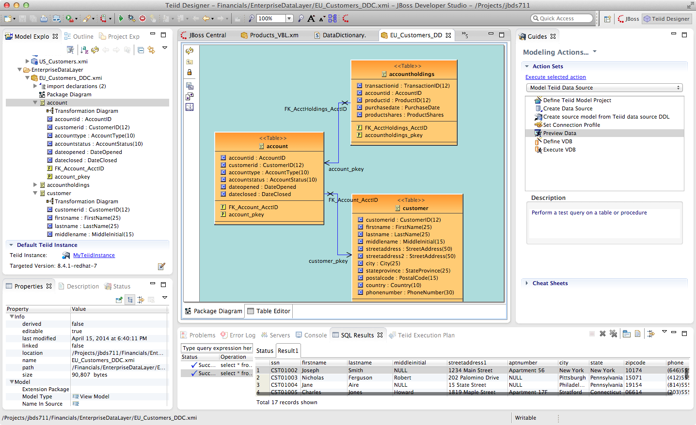
5.4 Create the US_Customers_DDC Enterprise Data Layer
Now that we have finished with building the first enterprise data service layer in our model, we can take a short-cut to creating the same type of model for the US_Customers model. Essentially we are going to use the EU_Customers_DDC model as a template for creating the US_Customers_DDC model, and then replace the sources of the transformations for each of the tables with the correct ones.
Here is how to do it:
Right-click on the EnterpriseDataLayer folder and select New -> Teiid Metadata Model. Fill in the wizard with the following fields (below) and click “Next”.

In the “New Model Wizard” window choose the EU_Customers_DDC model in the EnterpriseDataLayer folder and click “OK” followed by “Next >” and “Finish”. Your selection should be as indicated below.
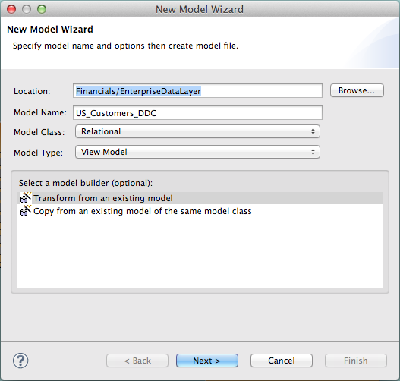

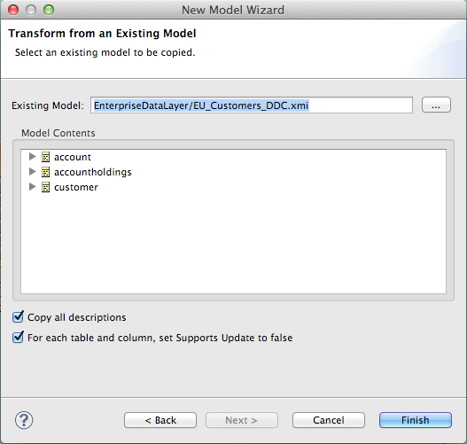

Open the Transformation Editor on US_Customers_DDC.customer. Note that the Source of the transformation is the EU_Customers_DDC.eucustomer table. We want to replace that with the US_Customers_VBL table. Right-click on the Source table and select "Remove Transformation Source(s)".
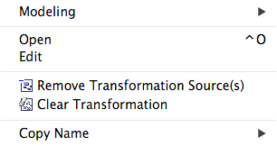

The following pop-up window will be presented.
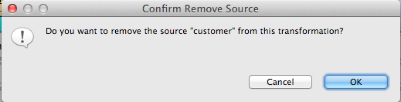

Click “OK”. The following illustration indicates what your view in Teiid Designer should now resemble.
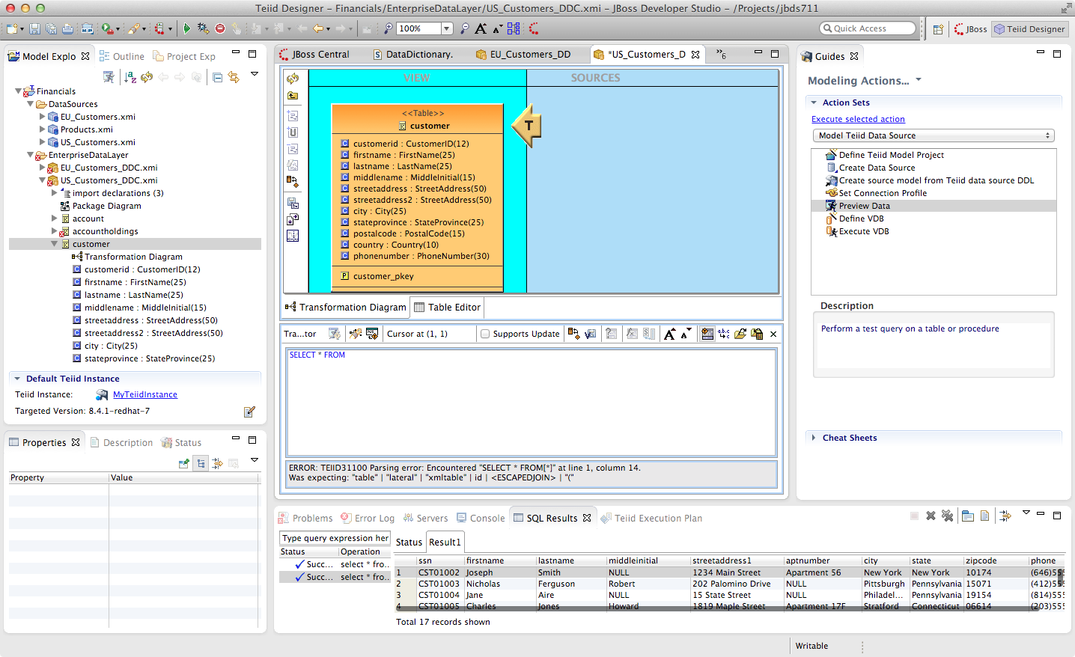

Select the VirtualBaseLayer -> US_Customers_VBL -> customer table. This is highlighted in the illustration below.
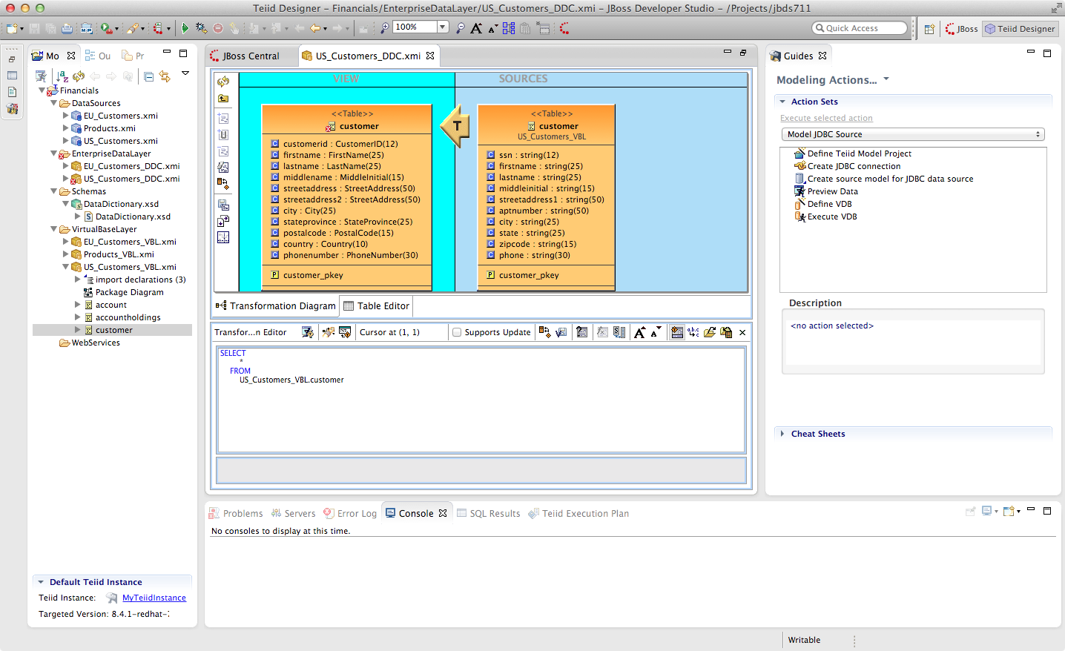
There will be an error on our current model, US_Customers_DDC. At this point, we need to add a source model. Simply drag the highlighted customer table indicated in the previous illustration to the sources column on the right-hand side. This will add this table from our VirtualBaseLayer to our US_Customers_DDC model.

As is indicated on the model, the transformation is valid but is not fully reconciled. Click on the reconciler to bring up the wizard. As you can see from the reconciler, we have a bit of work to do.
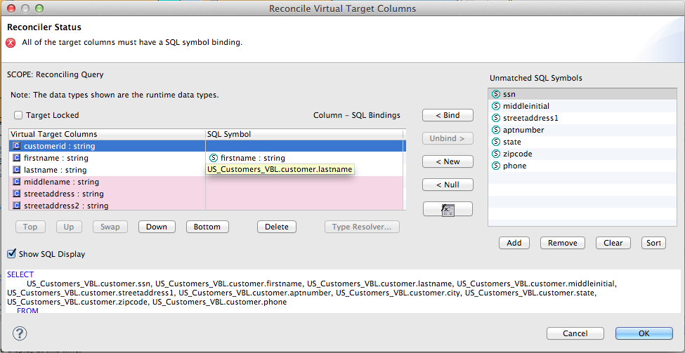
There are two things that we need to do in order to fix this transformation.
1. Assign (Bind) variables that do not automatically match. By selecting the source on the left and the target on the right, we can then bind each of the following:
- ssn to customerid
- middleinitial to middlename
- streetaddress1 to streetaddress
- aptnumber to streetaddress2
- state to stateprovince
- zipcode to postalcode
- phone to phonenumber (be sure to assign this on the left too and not map it to country!)

When we are finished with Step 1, we have one more step.
2. Create a (simple) function to assign a value to Country as it does not exist in the source. To do this we will open up the Expression Builder by clicking on the "f(x)" button. This is right under the "< Null" button in the middle area of the wizard. Since all that is needed is a simple (static) assignment, the Expression Builder comes up with the following screen.
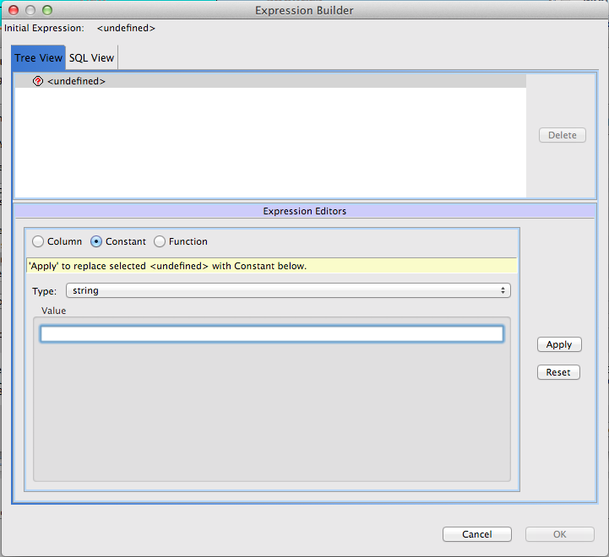
All we need to do is type "USA" into the Value field, click Apply, then OK. However, while you are in the Expression Builder, you may want to select the Function radio button to check out the many out-of-the-box functions and operations that ship with JBoss Data Virtualization. When you are finished, be sure to set it back to Constant and complete the instructions as outlined above.

When the Expression Builder exits back into the Reconciler, you will notice that the function ('USA' AS Country) has been properly assigned. Click “OK” in the Reconciler and save your changes.
Now perform the same process with the other two tables (Account and AccountHoldings). Delete the EU_Customers_DDC source and drag & drop the appropriate US_Customers_VBL source and perform any necessary reconciliations. Again, you can go through the required steps to Preview data that was outlined in an earlier lab.
The Data Dictionary has also defined enterprise types for Product data. Create a Products_DDC model in the EnterpriseDataLayer folder, source it from the Products_VBL model, and correct the datatypes in the DDC model. Finally, reconcile any datatype conversion issues.
Congratulations, you have completed Lab #5.

